Bug:   
no required field markers  
user will know if directly click button **Get Started**  
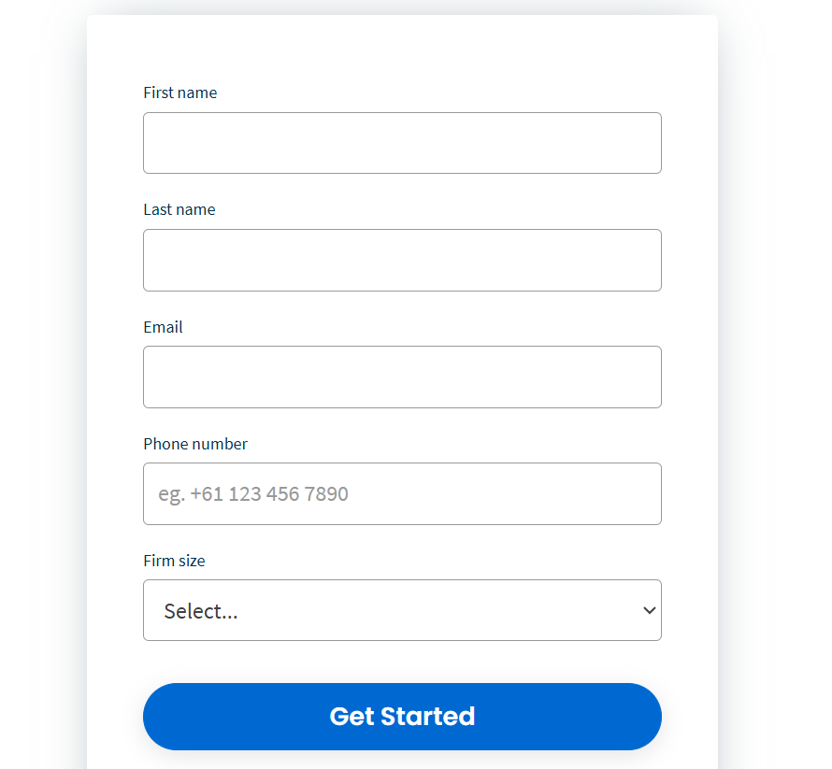  
2. Entering the email first feels kind of pointless. The system should really check if the email is already registered before moving on to the password part. Otherwise, that step doesn’t really make sense.   
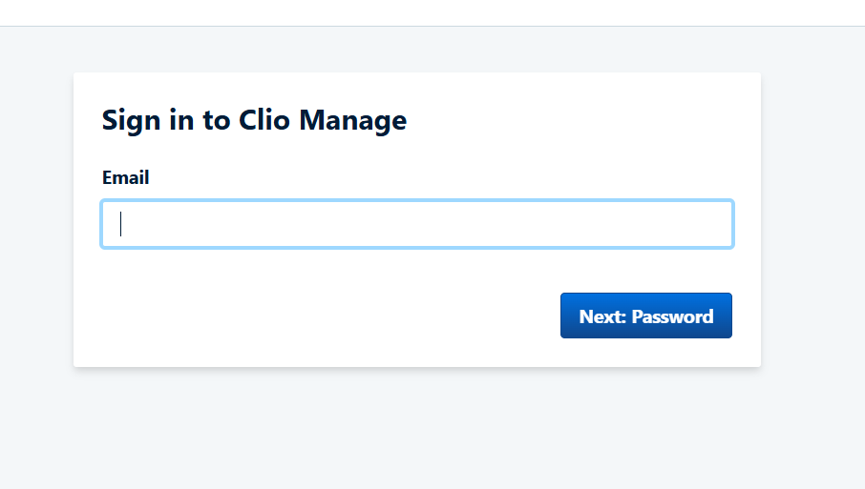

**Penjelasan BDD:**In my opinion, BDD (Behavior-Driven Development) is one approach that can be used in automated testing. BDD is different from CDD (Check-Driven Development) because it focuses more on explaining things in plain, human-readable language — almost like a recipe.

The key elements to pay attention to in BDD are the keywords: Given, When, Then, And, and Or. Given describes the initial step or context before the test starts, like accessing a page. When defines the main action or event that triggers the behavior. Then outlines what the expected outcome or result should be. One of the biggest advantages of BDD is that anyone continuing the testing later on can easily understand what’s going on, making collaboration and test maintenance much simpler.